**OBJECTIVES:**

* To learn about diodes in series.
* To learn about diodes in parallel.

**EQUIPMENT:**

* Diodes
* Connecting Wires
* Power Supply
* Ammeter
* Voltmeter

**THEORY:**

**DIODES IN SERIES:**

A single diode's reverse voltage rating may not be sufficient in very high voltage situations. The voltage rating is then increased by connecting two or more diodes in series. However, because the reverse voltage is not evenly distributed across the two diodes, the diode with the lesser leakage current may have an excessive reverse voltage across it. Even if we utilize the same number of diodes, their V-I characteristics may differ. The current rating of the diodes in series is the same as one of the diodes' current rating. Both series diodes have the same reverse leakage current in the reverse direction, but as indicated, they have distinct reverse voltage values. In this circumstance, diode D's reverse voltage rating may be exceeded.

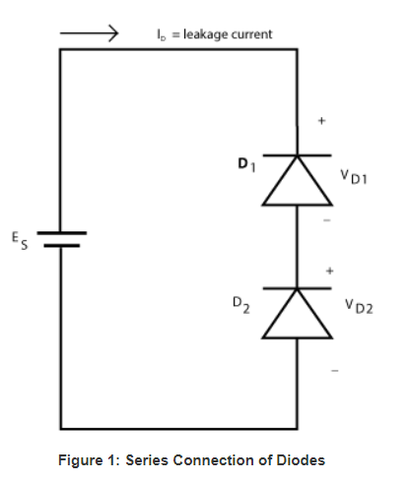

Forced voltage sharing may be achieved by putting appropriate voltage sharing resistors across each series diode. To be successful, the resistors must conduct a current significantly larger than the diode's leakage current. Because these sharing resistors will burn power during revere bias operation, it is critical to utilize the highest resistance available.

Furthermore, due to varying reverse recovery durations, there may be excessive reverse voltage across a diode. A capacitor linked in parallel with each diode (see Figure 4 below) will protect the diode from voltage transients.

**DIODES IN PARALLEL:**

If the load current is greater than the current rating of a single diode, then two or more diodes can be connected in parallel to achieve a higher forward current rating. Diodes connection in parallel do not share the current equally due to different forward bias characteristics. The diode with the lowest forward voltage drop will try to carry a larger current and can overheat. If these two diodes are connected in parallel at a given voltage, a different current flow in each diode. The total current flow is the sum of Ip1 and Ip2. The total current rating of the pair is not the sum of the maximum current rating for each but is a value that can be just larger than the rating of one diode alone.

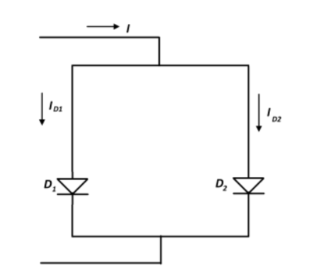

Parallel diodes can be forced to share current by connecting a very small resistor in series with each diode. The current sharing resistor R establishes values of ID1 and ID2 that are nearly equal. Although current sharing is very effective, the power loss in the resistor is very high. Furthermore, it causes an increase in voltage across the combination. Unless using a parallel arrangement is absolutely necessary, it is better to use one device with an adequate current rating.

**EXPERIMENT:**

**SERIES:**

* Connect the circuit given in the figure below.

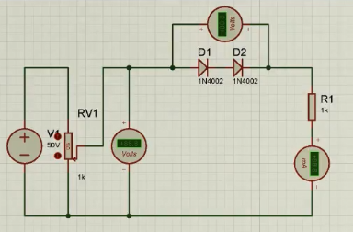

* Measure the voltage across diodes.
* Calculate the current I­D

**PARALLEL:**

* Connect the circuit given in the figure below.

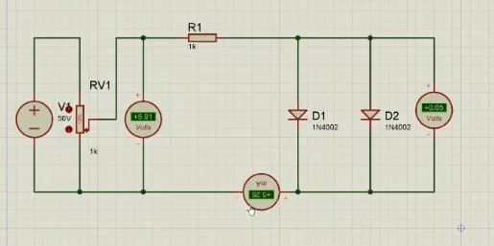

* Measure the voltage across diodes.
* Calculate the current I­D

**OBSERVATIONS:**

**SINGLE FORWARD DIODE (From Previous Lab):**

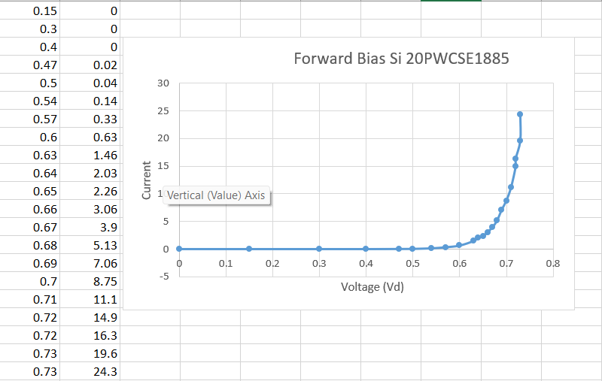

**SINGLE REVERSE DIODE (From Previous Lab):**

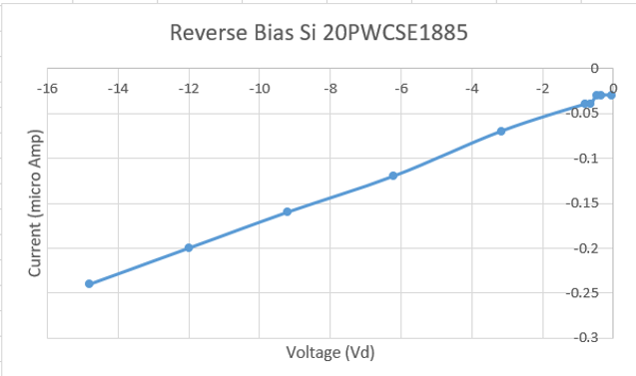

**SERIES FORWARD DIODE :**

The circuit is:

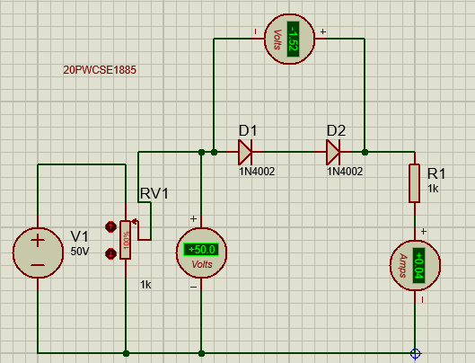

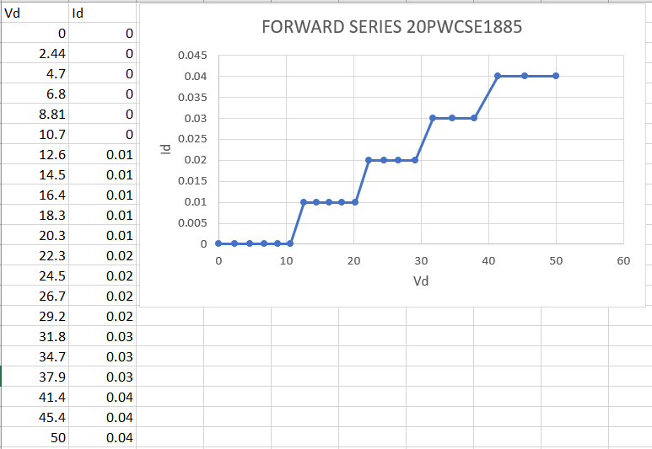

**SERIES REVERSE DIODE :**

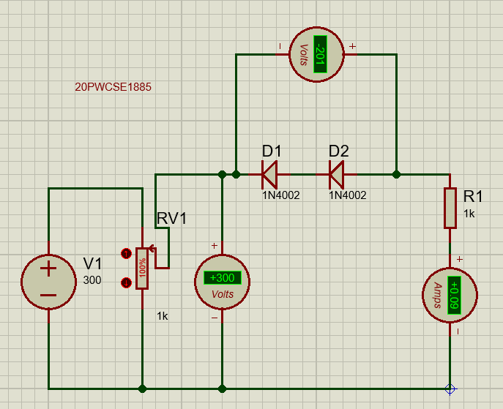

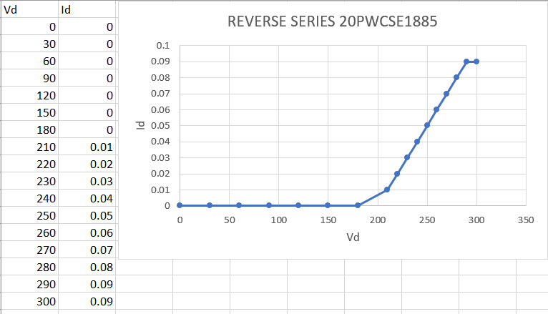

**PARALLEL FORWARD DIODE :**

The circuit is:

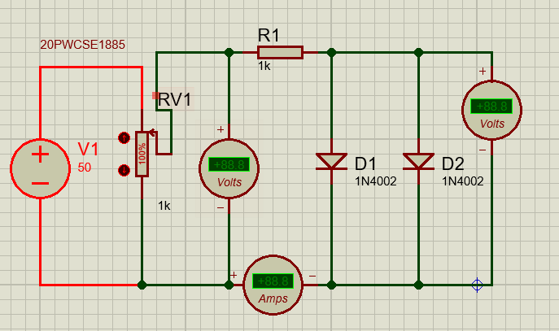

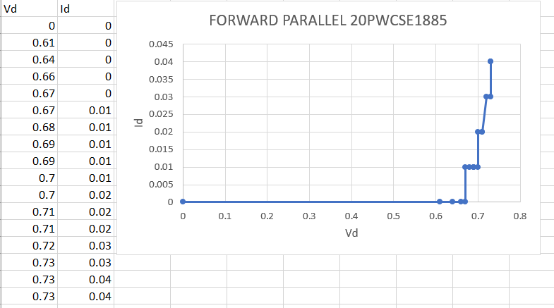

**PARALLEL REVERSE DIODE :**

